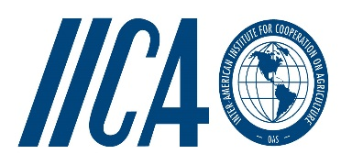

10TH EDF SPS Project
Support to the Caribbean Forum of ACP States in the Implementation of Commitments Undertaken Under the Economic Partnership Agreement (EPA):
Sanitary and Phytosanitary Measures (SPS)

Dear Sir/Madam

PROCUREMENT OF PROFESSIONAL SERVICES TO EVALUATE THE QUALITY OF HONEY
.

The Inter-American Institute for Cooperation on Agriculture (IICA), an international institution with the responsibility of executing the 10th EDF SPS Project is collaborating with the Caribbean Agricultural Health and Food Safety Agency (CAHFSA) to identify a suitable consultant to determine the quality of the honey traded in the region as well as its compliance with acceptable international standards.
The objective of this consultancy is to profile honey from three (3) of the major honey producing countries in the region in order to determine the quality of the honey and its compliance with acceptable international standards.

The contracted laboratory will be required to:

1. Review relevant international standards for honey and determine theirapplicability to the region.
2. Review existing methods and standards for honey produced and sold in the region and identify key parameters to be used in profiling honey.
3. Arrange for collection of samplesofhoney from the following three (3) honey producing countries in the region: Trinidad & Tobago, Guyana and Grenada.
4. Evaluate the samples of honey in an accredited laboratory based on theparameters identified in (2) above.
5. Prepare profiles of the samples, indicating where samples do not meet relevant international standards.

A final report is to be submitted within six (6) months of commencement of the project

Interested parties are kindly requested to submit a written proposal together with the cost for conducting the assignment, CVs of staff to be utilized to:

Chief Executive Officer
Caribbean Agricultural Health and Food Safety Agency
Letitia Vreisdelaan #10
Paramaribo, Suriname
E-mail: cahfsa14@gmail.com or info@cahfsa.org
Phone: 597-714-2085

Submission should be made by Thursday March 10, 2016

With best regards

Yours sincerely

L. Simeon Collins
CEO

