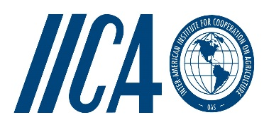

**10TH EDF SPS Project**

*Support to the Caribbean Forum of ACP States in the Implementation of Commitments Undertaken Under the Economic Partnership Agreement (EPA):*

*Sanitary and Phytosanitary Measures (SPS)*

Dear Sir/Madam

**PROCUREMENT OF PROFESSIONAL SERVICES TO EVALUATE THE QUALITY OF CASSAVA FLOUR**

The Inter-American Institute for Cooperation on Agriculture (IICA), an international institution with responsibility of executing the 10th EDF SPS Project is collaborating with the Caribbean Agricultural Health and Food Safety Agency (CAHFSA) to identify a suitable laboratory to evaluate the quality of cassava flour produced and imported in the region as a first step towards some level of standardization of the product

The objectives of this assignment are as follows:

- To evaluate cassava flour in the region to determine the baseline quality;

- Develop a standard that facilitates trade in cassava flour.

The contractedlaboratory will be required to:

* Conduct a literature search on existing standards for cassava flour used regionally and internationally;
* Develop a draft standard for cassava flour in the Caribbean based on the literature review;
* Sample and analyze cassava flour from the following four (4) major cassava flour Caribbean producing countries: Trinidad & Tobago, Suriname, Barbados and Jamaica as well as imported cassava flour using accredited facilities;
* Identify gaps, if any, between the quality of the existing cassava flour and the draft standard.
* Provide recommendations for closing any gaps identified.

A final report is to be submitted within six (6) months of commencement of the project

Interested parties are kindly requested to submit a written proposal together with the cost for conducting the assignment, CVs of staff to be utilized to:

C*hief Executive Officer*

*Caribbean Agricultural Health and Food Safety Agency*

*Letitia Vreisdelaan #10*

*Paramaribo, Suriname*

*E-mail:* [*cahfsa14@gmail.com*](mailto:cahfsa14@gmail.com)*or info@cahfsa.org*

*Phone: 597-714-2085*

**Submission should be made by Thursday March 10, 2016**

With best regards

Yours sincerely

L. Simeon Collins

CEO

CAHFSA