

Constitution of the Caribbean Association of Professional Statisticians (CAPS)
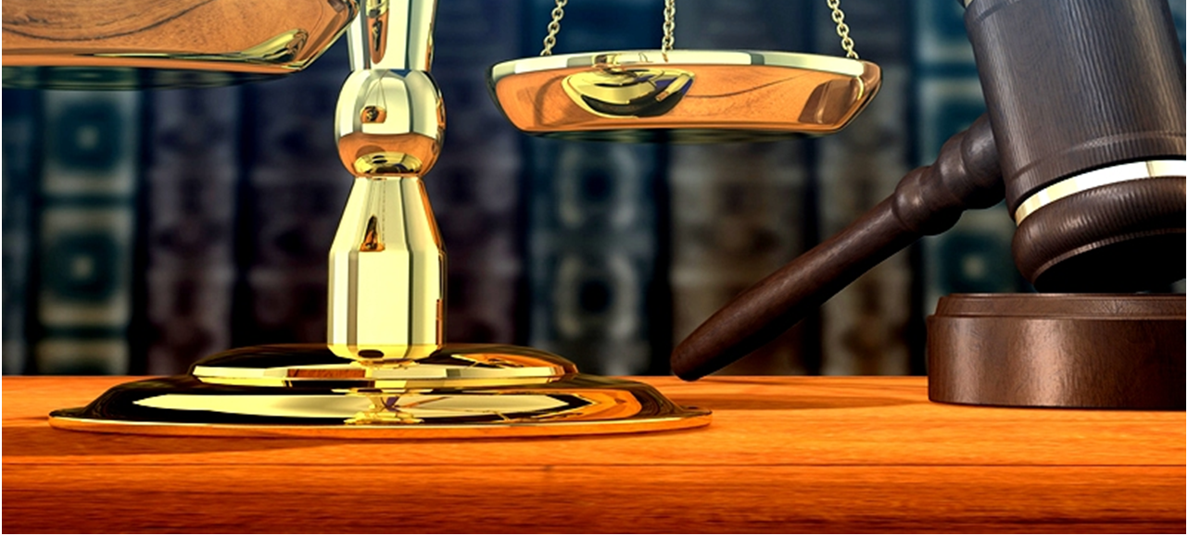
Constitution of the Caribbean Association of Professional Statisticians (CAPS), (Drafted using the ASA constitution)

Article I. NAME

The name of the organization is The Caribbean Association of Professional Statisticians (CAPS),
designated herein after as the Association

Article II. OBJECTIVES and ACTIVITIES

The objectives of the Association are:

- to promote the contribution of statistics and its applications to evidence based decision making in the CARICOM Region;

- to promote collaboration and discussion among professional statisticians

- to be a forum for discussion on statistical matters

- to promote the continuous training and development of professional statisticians

(5) to encourage research as it relates to statistical methodology and its applications, and to
publish and disseminate the findings.

(6) to promote a culture of statistical literacy, awareness and the general use of statistics in everyday life

The association is a nonprofit organization and achieves these objectives inter alia by conducting meetings, and making available information concerning the science of statistics and its contributions. It also cooperates with other organizations in the advancement of statistics, and promotes high professional standards and integrity in the application of statistics, fosters education in statistics, and, in general, makes statistics of service to society.

These objectives are pursued without prejudice toward any person or group.

Article III. MEMBERSHIP

The Association may have one or more categories of members, as follows:

- Full Members
- Student Members
- Retired Members
- Honorary Members
- Corporate/Institutional Members

Except as otherwise provided by this Constitution and By-Laws, the right to vote, to sign referendum petitions, to hold office, and to sign nominating petitions shall be reserved to full members.

Article IV. CHAPTERS

Members within any of the three specific geographic CARICOM areas may form a chapter to develop and explore ways of pursuing the objectives of the Association. The areas are as follows:

Area 1 – Anguilla, Antigua & Barbuda, Barbados, British Virgin Islands, Grenada, Montserrat, Dominica, St. Kitts & Nevis, St. Lucia, St. Vincent & The Grenadines.

Area 2 – Bahamas, Belize, Bermuda, Cayman Islands, Haiti, Jamaica, Turks & Caicos.

Area 3 – Aruba, Guyana ,Bonaire, Curacao, Suriname, Trinidad & Tobago.

Responsibility for chartering and overseeing chapters rests with the Council of Chapters.
The Council of Chapters functions under a charter approved by the Board of Directors to serve the needs of the chapters. As part of this function, it channels information between the Association and the chapters and promotes cooperation among the chapters. It also provides oversight for chapter activities, including formation and dissolution of chapters, and ensures that chapter activities, including fiscal management, are consistent with the goals of the Association. The Council shall consist of Chapter representatives and ex officio members as described in the charter of the Council of Chapters and elsewhere in the Constitution and By-Laws.

Article VI. BOARD OF DIRECTORS

The Board of Directors is the policy-making and legislative body of the Association. It shall consist of ten members, which are President, Past President two Vice Presidents, three representatives of the Council of Chapters, International Representative, Secretary and Treasurer. One Vice President will become President-Elect. The Secretary and Treasurer are ex officio members without vote. All voting members of the Board of Directors and the Treasurer must be full members of the Association for the three years preceding the start of their term of office. No employee of the Association, with the exception of the Secretary, may serve as a member of the Board of Directors.

The President, Past President, Vice Presidents, representatives of the Council of Chapters, and the International Representative shall collectively be known as the at-large Board members.

Article VII. EXECUTIVE COMMITTEE
The Executive Committee shall consist of the President, Past President, two Vice Presidents (one to become President-Elect), Secretary, and Treasurer. The Secretary and Treasurer are ex officio members without vote. This Committee shall conduct the business of the Association and shall report at the meetings of the Association.

Article VIII. OFFICERS

The officers of the Association shall be the President, Past President, two Vice Presidents, Secretary, and Treasurer.

Article IX. ELECTION OF OFFICERS / METHOD OF SELECTION

All full members shall be eligible to vote for the positions of President-Elect and Vice President.
The Council of Chapters shall nominate candidates for its representatives to the Board of Directors to be elected by a vote of all full members. Each of the (three) geographic regions, as established by the charter of the Council of Chapters, shall have one representative to the Board of Directors. The International Representative shall be elected by a vote of all full members. Candidates for International Representative shall be nominated as specified in Article V, Section 1 of the By-Laws. The Secretary and Treasurer shall be selected according to Article V, Section 2 of the By-Laws. The Executive Director shall serve as the Secretary. The Executive Director shall be hired by a vote of at least two-thirds of the Board of Directors. The Treasurer shall be appointed by the Board of Directors.

Article X. TERMS OF OFFICE

Once elected to the position of President, the incumbent shall normally serve a three-year term. The first two years shall be as President, and the third year as Past President. The Vice Presidents shall be elected for two-year terms. No Vice President shall be eligible for immediate re-election to the same office.

The representatives of the Council of Chapters shall serve a three-year term, one representative being elected each year. The International Representative shall be elected for a three-year term and shall not be eligible for immediate re-election to the same office.

The Board of Directors shall fix terms of office of five years or less for the Secretary and the Treasurer. The Secretary and the Treasurer may be re-appointed to the same office. The Board of Directors may provide shorter terms during periods of organizational transition. Terms of office shall end, and new terms shall begin, on January 1st, but each office holder shall serve until a successor takes office. No elected individual may serve simultaneously in two capacities on the Board of Directors.

Article XI. COMMITTEES

The committees of the Association shall consist of the Executive Committee and other committees of the Board of Directors, which are named in the By-Laws; Standing Committees, which are named in the By-Laws; and such Continuing and Ad hoc Committees as the President or the Board of Directors may establish.

Article XII. PUBLICATIONS

Publication of journals may be authorized by the Board of Directors. Other periodicals, reports, proceedings, or publications may be authorized in the By-Laws, by vote of the Board of Directors, or by the Council of Chapters.

Article XIV. MEETINGS

The Association shall hold an annual meeting (AGM) of the membership, at a time and place designated by the Board of Directors based upon recommendation from the Committee on Meetings. The AGM will be held during the second quarter of the year in order for members of statistical agencies whose approval for travel takes an extremely long time, have sufficient lead time to obtain that approval. Notice and Agenda of the annual meeting should be circulated to all members at least 28 days prior to the meeting. The Association may convene additional meetings/seminars as deemed necessary by the Board of Directors.

Article XV. AMENDMENTS

Amendments to the Constitution may be proposed by the Board of Directors or by a petition signed by at least 20% of the full members. An amendment originating by petition shall be referred to the Board of Directors, which shall vote on its recommendation regarding ratification. The Board of Directors may also decide upon the final wording of the proposed revision, as long as such wording is consistent with the original intent of the petition. Periodic revisions, as provided for in Article XII Section 2 of the By-Laws, shall be referred to the Board of Directors, which may recommend ratification as a whole or in parts.

As soon as feasible following action by the Board of Directors, the Secretary shall publish a copy of the proposed amendment in a news bulletin. The published copy shall include revisions by and recommendations of the Board of Directors and shall invite comments. Comments received shall be summarized or published in full in subsequent issues of a news bulletin. At least 30 days shall elapse between the mailing date of the news bulletin containing these comments and the vote on an amendment or revision. Regardless of the recommendation of the Board of Directors, an amendment proposed by petition must be submitted for vote. However, the Executive Committee may delay the vote to coincide with the next annual election. Ratification shall require an affirmative vote of at least two-thirds of the membership.

