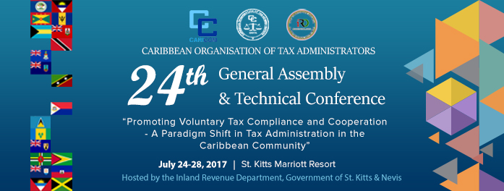
The Fifth COTA Essay Competition was conducted during the period February to June 2017. The topic for the 2017 Competition was –

If you were the Head of your country’s Tax Administration, how would you increase tax revenues for development?

The Regional Phase of the Competition received 17 entries from 8 participating countries. The entries were assessed by independent evaluators located in Barbados and Jamaica on the basis of the following criteria –

- Knowledge and understanding of the tax administration function, the country’s tax structure and current modernization drivers

- Relevance and depth of research

- Quality of argumentation

- Ingenuity of ideas and use of examples/illustrations

- Use of proper grammar and punctuation.

The Winners of the Fifth COTA Essay Competition are –

- Barbados – (Third Place) – Aliah Hazard, 15 years old – student of Elerslie Secondary School.

- Belize - (Second Place) – Monique Lamb, 15 years old – student of St Catherine Academy

- Montserrat – (First Place) – Shenika Jarvis, 15 years old – student of Montserrat Secondary School

All Winners will receive a Trophy and cash prizes as follows –

- First Place - US$1000.00

- Second Place Winner – US$750.00

- Third Place Winner – US$500.00

The Schools which the Winners attend will each receive an award as well.

The Caribbean Organisation of Tax Administrators wishes to commend the winners on their performance in the Essay Competition and to extend its best wishes to them in their future endeavours – hopefully as future tax administrators.

COTA also wishes to thank those Tax Administrations which coordinated the National –Level Competitions, particularly for their commitment to the COTA VISION. The prizes for the Competition were provided by all COTA Members through their contribution to the COTA Activities Budget.

The Trophies will be presented to the Winning Tax Administrations by the President of COTA.

24 July 2017

