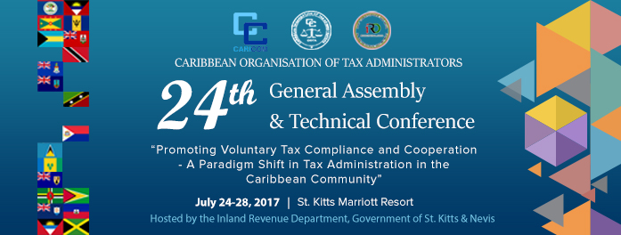

The COTA 2017 Appreciation Awardees are –

Ms Sabina Walcott-Denny – Barbados

Ms Beverley Williams – St Kitts and Nevis

Mr Kent Clare – Belize

Sabina Walcott-Denny, LLB, MBA, FCGA, FCPA – former Commissioner, Inland Revenue Department, Barbados

Ms Sabina Walcott-Denny served as Commissioner of the now defunct Inland Revenue Department prior to the restructuring of revenue collection functions in Barbados in 2014. In her role as Commissioner, Sabina championed the introduction of e-Filing for income tax returns in Barbados, taking the lead in that area in the Caribbean region at the time.

Ms Walcott-Denny’s career spanned over 45 years in public service. She has held posts which have influenced the public sector finance landscape in Barbados especially in the areas of taxation and national insurance. Mrs. Walcott-Denny has been a respected voice in tax administration for over 20 years. During this time she had the distinction of serving as president of the Commonwealth Association of Tax Administrators (CATA) and two terms as president of the Caribbean Organisation of Tax administrators (COTA). She has also represented the Government of Barbados in many areas of tax administration including as –

- A member of the Treaty Negotiation Team for almost 20 years;
- A member of the Anti-Money Laundering Board for 14 years;
- An advisor on the policy framework for the development and Implementation of VAT in Barbados;
- A member of the team that presented to the OECD Barbados’ case in respect of 1999 Harmful Taxation, which resulted in Barbados removal from the OECD list;
- An expert and a lead discussant for the United Nations Handbook on the Administration of Double Tax Treaties;
- A member of Barbados Revenue Authority Steering Committee.

Ms Walcott-Denny has also researched, written and presented several papers and workshops in the areas of Taxation, Management, Auditing and Customer Service at Conferences organized by –

- The Inter-American Center of Tax Administrator (CIAT)
- The Commonwealth Association of Tax Administrators (CATA)
- The Caribbean Organisation of Tax Administrator (COTA)
- The Caribbean Regional Technical Assistance Centre (CARTAC); and
- The United Nations.

Sabina holds a Bachelor of Laws from the Wolverhampton University and a Masters in Business Administration from Herriot-Watt University, both in the United Kingdom. She is a Fellow of the Certified General Accountants of Canada (CMA) and an accredited Alternative Dispute Resolution mediator.

Ms Sabina Walcott-Denny is awarded the COTA Appreciation Award for her dedication, outstanding service and contribution in the area of tax policy and administration in the Caribbean Community.

Ms Beverly Williams - former Comptroller, Inland Revenue Department, St Kitts and Nevis
Ms Williams commenced her tenure in the Civil Service of St Kitts and Nevis on 24th October 1968 having served as a Business Studies Teacher at the Cayon High School for 27 years. She was eventually assigned to the Inland Revenue Department in November 1995 in the capacity of Assistant Comptroller. She was appointed Deputy Comptroller on November 1995 and assumed the position of Comptroller, Inland Revenue Department in 2000. Ms Williams holds a B.A. in Business Accounting which she awarded in 1990.
During her tenure with the St Kitts and Nevis Inland Revenue Department, Ms Williams actively participated in the work of COTA having attended her first COTA General Assembly and Technical Conference in July 1996 held in Trinidad and Tobago and subsequently in Jamaica and the Bahamas
Ms Williams can best be described as Bold, Eloquent in speech and filled with vigor whose astute leadership has resulted in the St Kitts and Nevis Inland Revenue Department continuing to be recognized among the leaders in tax administration across the region.

Ms Beverly Williams is awarded the COTA Appreciation Award for her dedication, invaluable service and contribution in the area of tax administration in the Caribbean Community.

Mr Kent Clare – Former Commissioner, Income Tax Department, Belize
Mr Kent Clare, a career Public Officer, worked within the ranks of the Income Tax Department since June 1983, eventually ascending to the post of Commissioner in January 2011. As Commissioner, Mr Clare concentrated significant efforts on international taxation issues that were challenging the Belize jurisdiction including international tax transparency and cooperation, base erosion and profit shifting and the resultant organizational retrofitting required for the achievement of a ‘compliant’ rating. He was part of a small team that was established to assist Belize in navigating the Global Forum process (on exchange of tax information) that resulted in Belize achieving a ‘Mostly Compliant’ status.
Quite early in his career, Mr Clare recognized that very few governments in the Caribbean are sufficiently resourced to ably contend with the formidable legal and technical expertise that reside in the private sector and which, at times, pursue efforts that are adversarial to the public interest. As such, he advocated for the development of a capable, ethical and professional Public Service which can hold its own against high-powered private sector advocates.
Mr Clare holds a Bachelor of Science in Accounting from the University of Belize and a Masters in Professional Accounting from Colorado State University. He is the current Director of the Belize Financial Intelligence Unit, having assumed this position immediately upon his retirement as Commissioner of Income Tax in September 2016.

Mr Kent Clare is awarded the COTA Appreciation Award for his dedication, invaluable service and contribution in the area of tax administration in the Caribbean Community.

St Kitts and Nevis
24 July 2017

